

FINAL REPORT

(Token App For Parking System)

Submitted by

Usama Atta , Subhan Ali

# Department of Computer Science

Govt. Post Graduate College of Science Samanabad, Fsd.

2020

CERTIFICATE

This is certify that Mr. Usama Atta and Mr. Subhan Ali has been found satisfactory and according to the prescribed format. I recommend it be processed for evaluation by the internal Examiner for award of degree of Bachelor of Science in Computer Science.

Supervisor

Ashfaq Ahmed Signature:

# Internal Panel

Zeeshan Khalid Signature:

Mis Shahla Gul Signature:

# Project Coordinator Head of Department DECLARATION

The work reported in this Documentation was carried out by me under the supervision of “Sir Ashfaq Ahmed ”, skilled teacher of department of Computer Science, Govt. Post Graduate College of Science Samanabad Faisalabad, Pakistan.

I hereby declare that the title of the project “Token App (Parking system)” and the contents of project is my own. And no part has been copied from any project source code. I further declare that this work has not been submitted for any award of any other degree diploma. The college may take action if the information provided is found wrong.

Name : Usama Atta

Registration No : 2016-GCUF-063748

Name : Subhan Ali

Registration No : 2016-GCUF-063784

# ACKNOWLEDGEMENT

A project like this is never the work of anyone alone. The contributions of many people, in their different ways, have made it possible. we would like to extend my appreciation especially to the following.

Thank God for the wisdom and perseverance that he has been bestowed upon us during this project, and indeed, throughout our life: "we can do everything through him who gives us strength."

Sir Ashfaq Ahmed, helps for making this project possible. His support, guidance, advice throughout the project, as well as his pain-staking effort in proof reading the drafts, is greatly appreciated. Indeed, without his guidance, I would not be able to put the topic together. Thanks Sir to encouraging us to undertake the honors program. The experience has been an interesting and rewarding one. Of course, this project would not have been possible without the participation of the subjects.

Last but not least, we would like to thank my parents for their unconditional support, both financially and emotionally throughout my degree. In particular, the patience and understanding shown by my mother, father and brothers during the honors year is greatly appreciated. I know, at times, my temper is particularly trying.

# ABSTRACT

At present, Token App system is being utilized by me and by my friends. First of all, it require manually add user information like vehicle number vehicle type and vehicle image etc. This usually leads the entry of the vehicle in the parking area. This Application system is designed to improve accuracy and to enhance safety instead to carry a paper token or iron token. This App is very efficient in the parking Area. It is Mobile based system which helps the operator to improve inventory management, data management and keep record etc.

Table of Contents

INTRODUCTION .............................................................................................

1.1 Purpose of Project ..................................................................................................2

1.2 Project Scope ..........................................................................................................3

1.3 Project Planning .....................................................................................................3

1.4 Risk Management ..................................................................................................3

1.5 Project Risk ............................................................................................................4

1.6 Product Risk ...........................................................................................................4

Background ..................................................................................................... 5

2.1 Area of studies ................................................................................................................... 6

2.2 Tools .................................................................................................................................. 6

2.3 Hardware and Software Requirement ........................................................................... 6 2.4 Main Reasons of Development ........................................................................................ 7 System Requirement and Specifications .........................................................

3.1 Objective of project .......................................................................................................... 9

3.2 Existing Methodologies .................................................................................................... 9

3.3 Adapted Methodology ................................................................................................... 10

3.4 System Functional and Non-functional Requirements ............................................... 12

3.5 Interface Specifications ................................................................................................. 13

3.5 Feasibility Studies .......................................................................................................... 14

System Design ...................................................................................................

4.1 Use Case Diagram .......................................................................................................... 16

4.2 Activity Diagram ............................................................................................................ 17

4.3 Entity Relationship Diagram ........................................................................................ 18 4.4 System Diagrams ............................................................................................................ 19

Implementation and Testing.............................................................................

5.1 Testing Methods ............................................................................................................. 26

5.2 Test Cases ....................................................................................................................... 27

5.3 Integration Testing ........................................................................................................ 37

5.4 Customer Evaluation Report ........................................................................................ 37 Manual .............................................................................................................

6.1 Screen Shots of Project Modules .................................................................................. 39

6.2 Conclusion and future extensions .......................................................................57

# List of Figures

FIGURES ..........................................................................................................

Figure no. 1: Waterfall Model .................................................................................................. 9

Figure no. 2: RAD Model ........................................................................................................ 10 Figure no. 3: Iterative Model .................................................................................................. 11

Figure no. 4: Use Case Diagram ............................................................................................. 16 Figure no. 5: Data Flow Diagram ........................................................................................... 17

Figure no. 6: Entity Diagram .................................................................................................. 18 Figure no. 7: Use case diagram 1 ............................................................................................ 19

Figure no. 8: Use case diagram 2 ............................................................................................ 20

Figure no. 9: Use case diagram 3 ............................................................................................ 21

Figure no. 10: Use case diagram 4 .......................................................................................... 22

Figure no. 11: Use case diagram 5 .......................................................................................... 23

Figure no. 12: Use case diagram 6 .......................................................................................... 24

Figure no. 13: Module 1 ........................................................................................................... 39

Figure no. 14: Module 2 ........................................................................................................... 39

Figure no. 15: Module 3 ........................................................................................................... 40

Figure no. 16: Module 4 ........................................................................................................... 40

Figure no. 17: Module 5 ........................................................................................................... 41

Figure no. 18: Module 6 ........................................................................................................... 42

Figure no. 19: Module 7 ........................................................................................................... 43

Figure no. 20: Module 8 ........................................................................................................... 44

Figure no. 21: Module 9 ........................................................................................................... 45

Figure no. 22: Module 10 ......................................................................................................... 46

Figure no. 23: Module 11 ......................................................................................................... 46

Figure no. 24: Module 12 ......................................................................................................... 47

Figure no. 25: Module 13 ......................................................................................................... 48 Figure no. 26: Module 14 ......................................................................................................... 49

Figure no. 27: Module 15 ......................................................................................................... 50

Figure no. 28: Module 16 ......................................................................................................... 51

Figure no. 29: Module 17 ......................................................................................................... 52

Figure no. 30: Module 18 ......................................................................................................... 52

Figure no. 31: Module 19 ......................................................................................................... 53

Figure no. 32: Module 20 ......................................................................................................... 54

Figure no. 33: Module 21 ......................................................................................................... 55

Figure no. 34: Module 22 ......................................................................................................... 55

Figure no. 35: Module 23 ......................................................................................................... 56

Figure no. 36: Module 24 ......................................................................................................... 56

Figure no. 37: Module 25 ......................................................................................................... 57

Figure no. 38: Module 26 ......................................................................................................... 58

List of Tables

TABLES ............................................................................................................

Table no. 1 Test Case: 1 .......................................................................................................... 27

Table no. 2 Test Case: 2 .......................................................................................................... 27

Table no. 3 Test Case: 3 .......................................................................................................... 28

Table no. 4 Test Case: 4 .......................................................................................................... 28

Table no. 5 Test Case: 5 .......................................................................................................... 29

Table no. 6 Test Case: 6 ........................................................................................................... 29

Table no. 7 Test Case: 7 .......................................................................................................... 30

Table no. 8 Test Case: 8 .......................................................................................................... 30

Table no. 9 Test Case: 9 ........................................................................................................... 31

Table no. 10 Test Case: 10 ...................................................................................................... 31

Table no. 11 Test Case: 11 ....................................................................................................... 32

Table no. 12 Test Case: 12 ...................................................................................................... 32

Table no. 13 Test Case: 13 ...................................................................................................... 33

Table no. 14 Test Case: 14 ...................................................................................................... 33

Table no. 15 Test Case: 15 ...................................................................................................... 34

Table no. 16 Test Case: 16 ...................................................................................................... 34

Table no. 17 Test Case: 17 ...................................................................................................... 35

Table no. 18 Test Case: 18 ...................................................................................................... 35

List of Tables

TABLES ............................................................................................................

Table no. 1 Test Case: 1 .......................................................................................................... 27

Table no. 2 Test Case: 2 .......................................................................................................... 27

Table no. 3 Test Case: 3 .......................................................................................................... 28

Table no. 4 Test Case: 4 .......................................................................................................... 28

Table no. 5 Test Case: 5 .......................................................................................................... 29

Table no. 6 Test Case: 6 ........................................................................................................... 29

Table no. 7 Test Case: 7 .......................................................................................................... 30

Table no. 8 Test Case: 8 .......................................................................................................... 30

Table no. 9 Test Case: 9 ........................................................................................................... 31

Table no. 10 Test Case: 10 ...................................................................................................... 31

Table no. 11 Test Case: 11 ....................................................................................................... 32

Table no. 12 Test Case: 12 ...................................................................................................... 32

Table no. 13 Test Case: 13 ...................................................................................................... 33

Table no. 14 Test Case: 14 ...................................................................................................... 33

Table no. 15 Test Case: 15 ...................................................................................................... 34

Table no. 16 Test Case: 16 ...................................................................................................... 34

Table no. 17 Test Case: 17 ...................................................................................................... 35

Table no. 18 Test Case: 18 ...................................................................................................... 35

# CHAPTER - 1

## Project Introduction

INTRODUCTION

This project is mainly developed to manage the record of parking digitally so that the record will remain available for a long time without error. The record is saved in the database so we can retrieve specific data any time whenever we want. Manage the Inventory of user easily without error.

In this the image system is a system which make it more secure and unique.

The software has many functionalities such as

* View
* Map
* Chart
* List

1.2 Purpose of this Project

The main purpose of this application is to reduce the complexity and difficulty in real life problem that we face in our parking system. For example, when a person park his car he has to take a token and take care of it. If he lose the token, he has to pay the fine. All of these problems can be avoided by using this application.

This project is mainly developed to manage the record of parking digitally so that the record will remain available for a long time without error. The record is saved in the database so we can retrieve specific data any time whenever we want. Manage the Inventory of user easily without error.

In this the image system is a system which make it more secure and unique.

This project is amid to manage records and control inventory of the vehicle. Our parking system is currently having a manual system which is not a technical way to control the flow of vehicle record. This manual system is also has many problems. For example data and hard copy of record can be damaged or misplaced so finding record in such situation is very difficult, sometimes it may take more time to finding proper result. To overcome these problem and provide a good and automated system this project has been taken.

It manages the daily users of the organization or any public place by registering them and also keeps the record of their Entry on daily bases.

1.3 Project scope

As you know in our country every citizen use parking in daily life on many places.

This application is suitable, compatible and easy to use on public place or any organizational place for the parking system. For example. shoping malls, factories, marketplace and many other private and public places

The basic purpose of this Application is to manage the all records and maintain the flow of vehicle digitally. Basically, it will be used for managing large number of data digitally so that data of vehicle can remain intact for a long time without error and can be used further.

The purpose of our system to help to save time for authorizes from manual work.

The system handles all the operations and generates reports in seconds.

1.4 Project Planning

After selecting this **project** we have to plan how to complete it. So this project, **Token App** was a great task for me and for my project member.

First of all, we consulted our supervisor and took guidelines to start the project, after that analyzed the project, saw how to manual system works, and took synopses of each aspect of the project. We consulted with the User and took requirements and started to plan working on the project according to given requirements.

We planned to visit different places on weekly bases and started to work on project according to their requirements.

After that I divided the project in three phases.

* + Designing
  + coding
  + implementation

1.5 Risk Management

The basic risks involved in the project were the “System Familiarity” and the “System Support”.

The elimination of such risks was made possible by making sure, the system was “User Friendly , efficient and Interactive”, and by assuring there was adequate support for the system to work i.e. in the form of the Computer systems that could serve the purposes, without slowing down the performance, otherwise the system would have been of no use. Fortunately, our system doesn’t need much of such processing requirements and most of the system can easily accommodate this application. In business the forecasting and evaluation of financial risks together with the identification of procedures to avoid or minimize their impact. Upon the completion of the project, we will analyzed risks. Based on this analysis, develop risk management process to minimize its impact on project.

1.6 Project risk

* The methodology to solve the problem can’t work in a proper manner.
* Budget does not enough or there is no budget.
* Hardware requirements can’t come in the time

1.7 Product Risk

* If the application user lose internet connection then the system can’t work
* If the user **Delete** some data by mistake, it can create an issue.
* Any fault in existing device.

# CHAPTER - 2

## Background

BACKGROUND

2.1 Area of Studies

This section is related to the description of the system specifications and the tools that were used to design and develop the project.

2.2 Hardware and Software Requirements

* Software Requirements:
* Microsoft Windows (7, 8, 8.1, 10) or Linux.
* Web browser like chrome, opera etc
* Simulator or Android Device
* Hardware Requirements:
* Minimum 4GB RAM
* Minimum 4GB space of Hard Disk.

2.3 Tools & Technology

Tools & technology are the backbone of any system. If there is no tool to develop the system, then there is no meaning of any system. Tools are very necessary for any system. That’s why we have also a combination of tools like:

* Visual studio code (Editor used to write code)
* React native (expo cli)
* Node.js (used for backend)
* Mongodb (Database)
* Github (Used for remote repository)

2.4 Reason of Development

This project is aimed to manage records and control inventory of vehicle digitally. The shop is currently having a manual system which is not a technical way to control the flow of record. This manual system is also has many problems. For example data and hard copy can be damaged or misplaced so finding record in such situation is very difficult, sometimes it may take days to finding proper result.

To overcome these problem and provide a good and automated system this project has been taken. Here the technique we already store data in our data base along with detail to use this data to manage the record of vehicle as well as the data will also be used by the owner.

2.4.1 Main Reasons to Development

* Manage data digitally
* Privacy and security
* Secure System
* Easily manage list without error
* Generate Reports
* Less time consuming

# CHAPTER - 3

## System Requirement Specification

SYSTEM REQUIREMENT SPECIFICATION

3.1 Objectives of the Project

1. Security of data:

Before this site, admin was maintained records manually on register. There was no security for this existing system. So now in this system, we provide security for Customer record according to his requirement. Now no one would capable to check the record else Admin/System User.

1. Retrieving data fast:

In existing system, User manages record manually. But due to this product he should be capable to retrieve data fast. The procedure of data retrieval becomes much faster as compared to manual procedures of retrieving the required information.

1. Record management:

In this system, the software will manage the record that are stay in parking by registering them, entry marking on daily bases.

Reports:

The system will generate list for the vehicles that contains all details of their in and out time.

1. Manage Entry:

In this Manage entry of the vehicles easily without error or manage stock of vehicle which is in the record.

3.1.2 Problems

The existing system used by the Parking owner is manual. Members use manual approach for these tasks which waste so much time. For example, a user come finding his data after some days they will find the register of specific time and then the details about his item and if the data is find the data is still intact then the customer will get his/her data.

In manual system the data is saved in hard copy which can damage in many ways and finding record in this system is very challenging and difficult task.

This manual system also has many problems. To overcome these problems and provide a good and automated system this project has been taken.

3.2 Existing Methodologies

The methodologies have the common phases like:

* Requirements
* Analysis
* Design
* Coding
* Testing
* Implementation

A software development methodology or system development methodology is a framework that is use to structure, plan and control the process of developing an information system. Some methodologies are given below:

* + - Waterfall model
    - Rad Model
    - Agile Model
    - Iterative Model

3.2.1 Waterfall Model:

The waterfall model is a sequential design process, used in software development processes, in which progress is seen as flowing steadily downwards (like a waterfall) through the phases of conception, requirements, analysis, design, construction, testing,

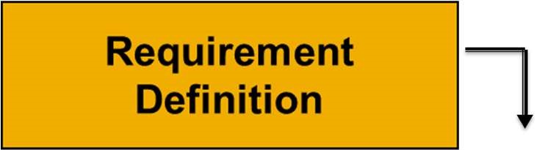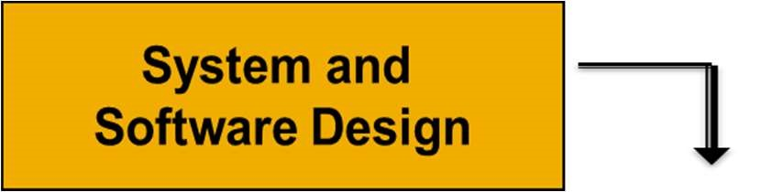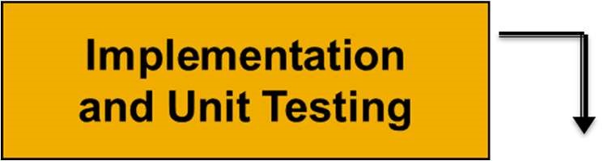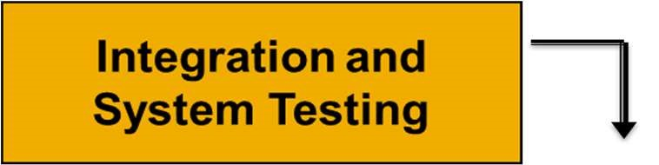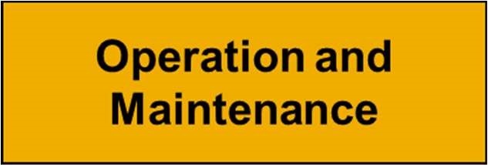

Figure No.1 VMS WATERFALL MODEL

3.2.2 Rad Model

Rad is also called Rapid Application Development Model. Rad should be used only when a system can be modularized to deliver in incremental manner.in this the components are developed in parallel manner. It is a faster software development process.it should be used if there is high availability of designers modeling.

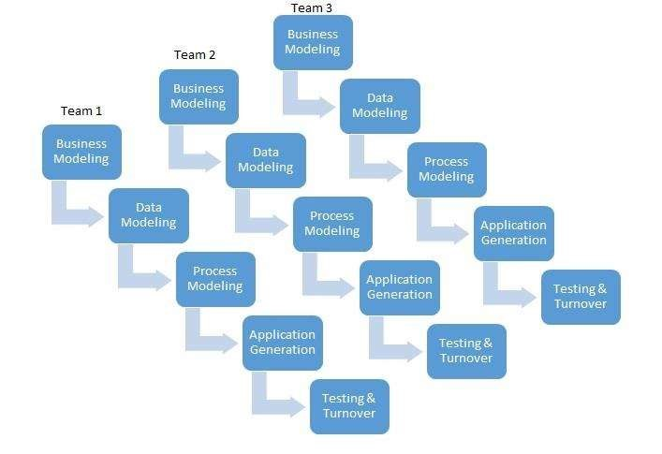

Figure No. 2 RAD MODEL

3.3 Adapted Methodology:

I used iterative methodology for my project. It was best for project.

An iterative life cycle model does not attempt to start with a full specification of requirements. Instead, development begins by specifying and implementing just part of the software, which can then be reviewed in order to identify further requirements. This process is then repeated, producing a new version of the software for each cycle of the model.

3.3.1 Iterative Model

A process for arriving at a decision or desired result by repeating rounds of analysis or a cycle of operations. The objective is to bring the desired decision or result closer to discovery with each repetition (iteration). The iterative process can be used where the decision is not easily recoverable or where the consequences of revocation could be costly.

Iterative Relationship between Successive Development Phases

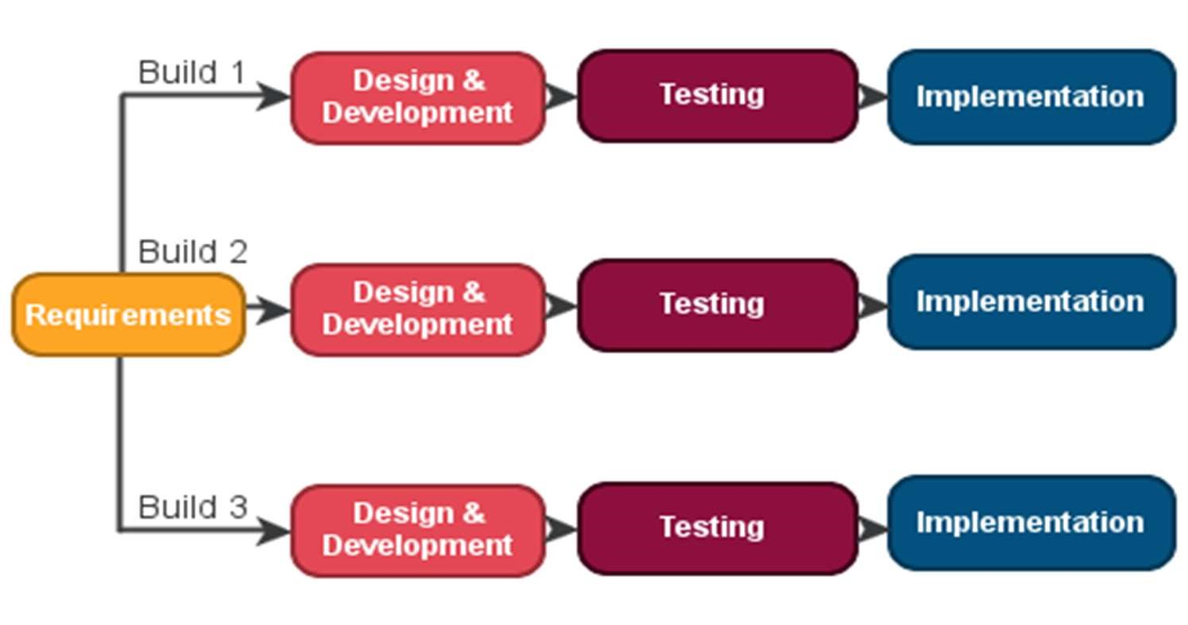

### Figure No. 3 ITERARTIVE MODEL

3.3.2 Reasons for Choosing the Methodology

I used this methodology because if User wants to change the requirements at any condition then we should able to improve the product as according to new requirements of User.

* + - In iterative model I am building and improving the product step by step.
    - In iterative model I can get the reliable Customer feedback.
    - In iterative model Major requirements must be defined however, some details can evolve with time.
    - It allows developer to break down the task of developing a system into a series of smaller tasks.
    - In iterative model I am building and improving the product step by step. Hence I can track the defects at early stages. This avoids the downward flow of the defects.
    - In iterative model I can get the reliable user feedback. When presenting sketches and blueprints of the product to users for their feedback, I can effectively ask them to imagine how the product will work

3.4 System Functional Requirements

In system functional requirements we are describing that what things will be done in the project.

* + - In this system all functionality is done by admin and user who can add, delete and update.
    - It manages have the facility to manage the record of vehicles, every month.
    - Admin manages the customers of the organization by registering them and also keeps the record of their attendance on daily bases.
    - It generates reports.
    - Our program provide functionality to generate invoices.
    - Invoice provide to the customer with the invoice no, product, type, grand total, customer name and vehicle number.

3.4.1 Interface requirements

The interface is highly user friendly. Labeled text boxes and buttons are used that’s why a computer illiterate user can also perform different tasks on the system easily. There are some fields that accept only numeric data. There are some fields that accept the text data. The date field only accepts the dates before the current date.

3.4.2 Regulatory Requirements

The system will have complete access to Admin or Controller who control software only who can manage all kinds of transactions and generates reports and invoice and send message to customers.

3.4.3 Security Requirements

In security requirements the following things/points are required:

• Admin/User login is provide security to unauthorized access.

•

3.4.4 System Non-functional requirements

In system non-functional requirements we are describing that how the performance of the project will work. How much the project will work efficiently? How the project provide the safety. How the project provide the security to avoid from the unauthorized access.

3.4.5 Performance Requirements

The system will take minimum time to access data from database. Customer get invoices.

3.4.6 Safety Requirements

To prevent data loss in case of system failure, we provide backup function to backup all data added by user.

3.4.7 Security Requirements

System needs username and password to secure our system privacy. If anyone wants to use it or hack it he/she will not allow using system.

3.5 Interface specifications

3.5.1 Software Quality Attributes

* + - * The Quality of the System is maintained in such a way, that the system is made user friendly.
      * The system quality attributes are assumed as under:
      * Accurate and hence reliable.
      * Secured.
      * Fast speed.
      * Compatibility.

System Interfaces:

This section describes how the system interfaces with other software products or Customers for input or output.

3.5.2 Customer Interface:

Application will be accessed over the Android device. The system would be fully compatible with Android Operating system. No User would be able to access any part of the application without logging on to the system.

3.5.3 Hardware Interfaces:

* + - Minimum 1GB RAM.
    - Minimum 2GB space of Hard Disk.

3.5.4 Software Interfaces:

* + - Android (5.1 and above)

3.6 Feasibility Studies

Feasibility study is to study about the problem and carries out the best system which meets all the requirements which is needed or necessary. Feasibility study is determining the financially and technically study to develop the system. They involve in analysis the problem and collect all the information about it.

3.6.1 Technical Feasibility

* + - Specifying equipment and system that will successfully satisfy the User requirement.
    - The facility to produce outputs in a given time.
    - Response time under certain conditions.
    - Ability to process and generate repots at a particular speed.
    - In technical feasibility, configuration of the system is given more importance than the actual makes of hardware. What speeds of input and output should be achieved at particular quality of printing.

3.6.2 Operational Feasibility

* + - What changes will be brought with the system?
    - What organizational structures are disturbed?
    - What new skills will be required? Do the existing staff members have these skills? If not, can they be trained in due course of time?

In this operational feasibility is operate the system a person should able to knowing about the system and easily understand to it they should be skilled full if system generate any error the person how controls it should be able to remove it or manage.

# CHAPTER - 4

## System Design

SYSTEM DESIGN

4.1 USE CASE DIAGRAM

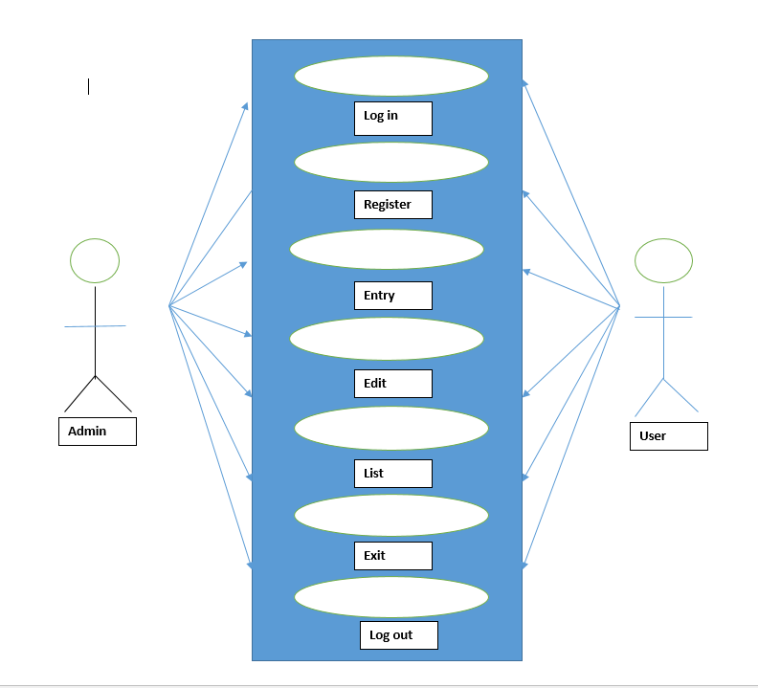

Figure No. 4 Use Case Diagram

4.2 Activity Diagram

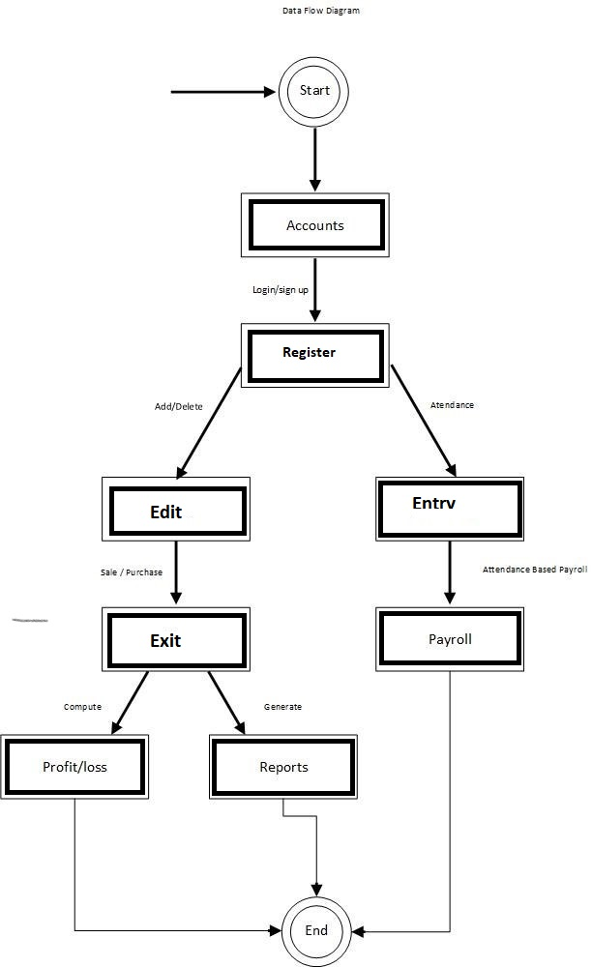

### Figure No. 5 Data Flow Diagram

4.3 Entity Relationship Diagram

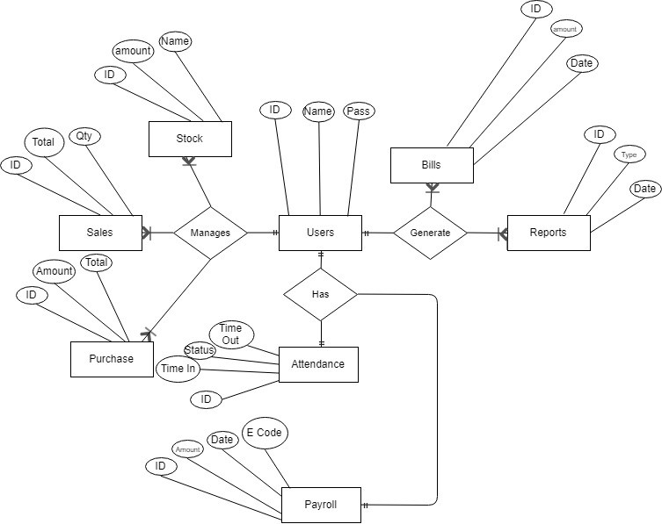

### Figure No. 6 Entity Relationship Diagram

4.5 Sequence Diagrams:

4.5.1 Add New Product System Sequence Diagram

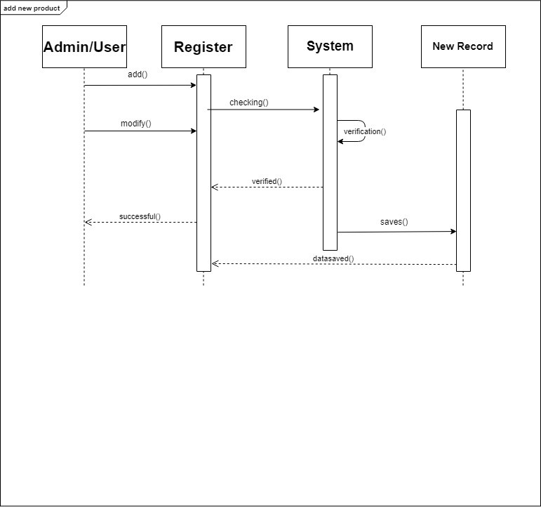

Figure No. 7 Sequence Diagram 1

4.5.2 Modify Product System Sequence Diagram

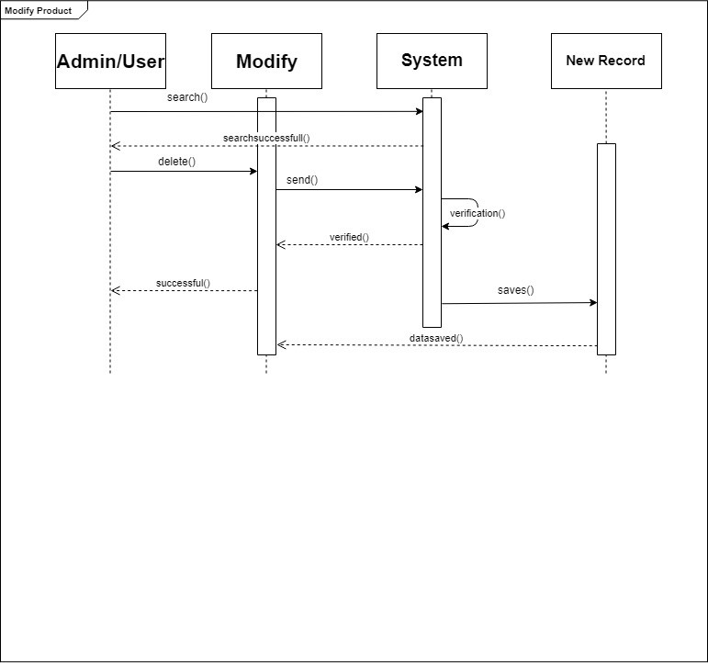

Figure No. 8 Sequence Diagram 2

4.5.3 Delete Product System Sequence Diagram

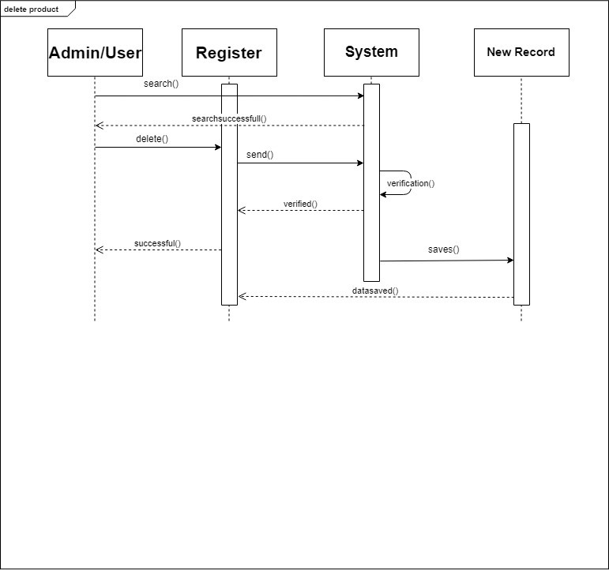

Figure No. 9 Sequence Diagram 3

4.5.4 Add New Employee System Sequence Diagram

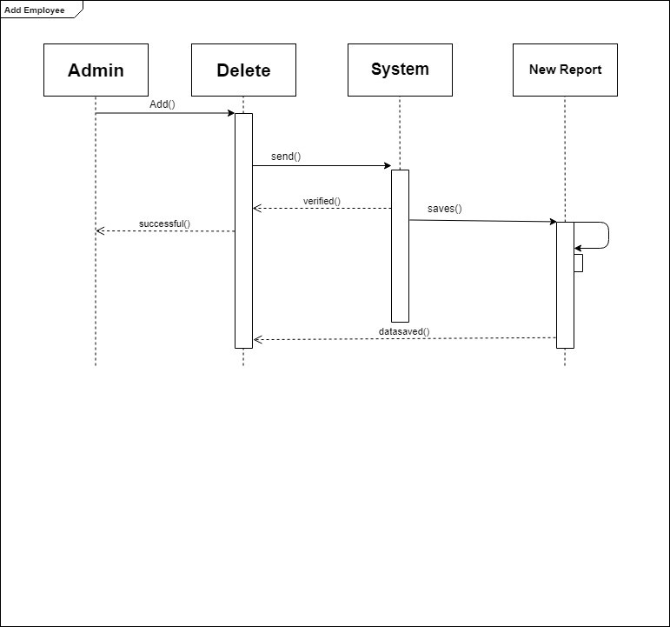

Figure No. 10 Sequence Diagram 4

4.5.5 Modify Employee System Sequence Diagram

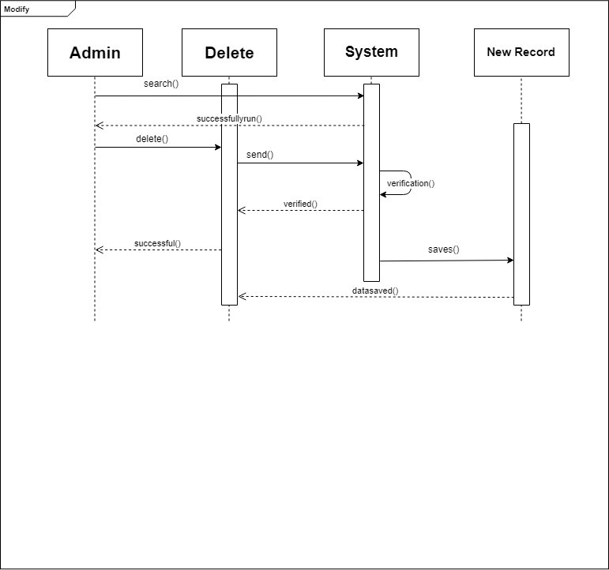

Figure No. 11 Sequence Diagram 5

4.5.6 Delete Employee System Sequence Diagram

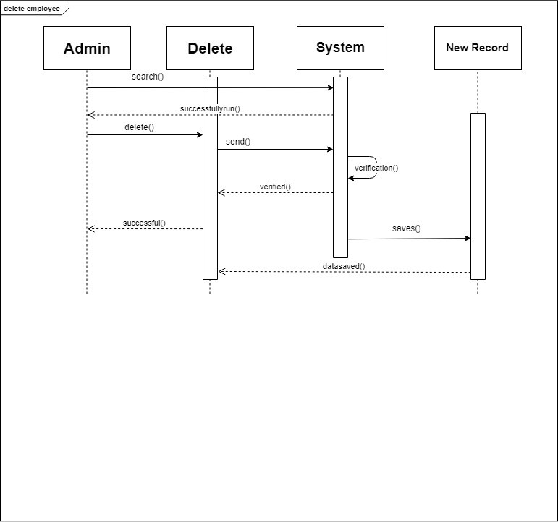

Figure No. 12 Sequence Diagram 6

# CHAPTER - 5

## Implementation & Testing

IMPLEMENTATION AND SYSTEM TESTING

5.1 Testing Methods

There are different methods which can be used for system testing. This chapter briefly describes those methods.

5.1.1 Black Box Testing

The technique of testing without having any knowledge of the interior workings of the application is Black Box testing. The tester is oblivious to the system architecture and does not have access to the source code. Typically, when performing a black box test, a tester will interact with the system's Customer interface by providing inputs and examining outputs without knowing how and where the inputs are worked upon.

5.1.2 White Box Testing

White box testing is the detailed investigation of internal logic and structure of the code. White box testing is also called glass testing or open box testing. In order to perform white box testing on an application, the tester needs to possess knowledge of the internal working of the code.

The tester needs to have a look inside the source code and find out which unit/chunk of the code is behaving inappropriately.

5.1.3 Grey Box Testing

Grey Box testing is a technique to test the application with limited knowledge of the internal workings of an application. In software testing, the term the more you know the better carries a lot of weight when testing an application.

Mastering the domain of a system always gives the tester an edge over someone with limited domain knowledge. Unlike black box testing, where the tester only tests the application's Customer interface, in grey box testing, the tester has access to design documents and the database. Having this knowledge, the tester is able to better prepare test data and test scenarios when making the test plan.

5.2 TEST CASE

|  |
| --- |
| Test Case ID: Test 1 Test Engineer: Usama Atta |
| Objective: Verify that system initialize successfully  Product: Token App  Environment: Application Based  Pre-Requisite: Initialize Successfully |
| Methods:  Initialization successful |
| Comments: Passed |

Table no. 1: Test Case 1

|  |
| --- |
| Test Case ID: Test 2 Test Engineer: Subhan Ali |
| Objective: Verify that interface is displayed  Product: Token App  Environment: Application Based  Pre-Requisite: Application open Successfully |
| Methods:  Launch the Application  Interface Displayed Successful |
| Comments: Passed |

Table no. 2: Test Case 2

|  |
| --- |
| Test Case ID: Test 3 Test Engineer: Usama Atta |
| Objective: Verify that admin/user login successfully  Product: Token App  Environment: Application Based  Pre-Requisite: Login page displayed successfully |
| Methods:  Launch the Application page  Admin login successful |
| Comments: Passed |

Table no. 3: Test Case 3

|  |
| --- |
| Test Case ID: Test 4 Test Engineer: Subhan Ali |
| Objective: Verify that system run successfully  Product: Token App  Environment: Application Based  Pre-Requisite: Data Inserted Successfully |
| Methods:  Launch the Application  Main Items inserted Successfully |
| Comments: Passed |

Table no. 4: Test Case 4

|  |
| --- |
| Test Case ID: Test 5 Test Engineer: Usama Atta |
| Objective: Verify that the record is retrieved successfully  Product: Token App  Environment: Application Based  Pre-Requisite: Data Inserted Successfully |
| Methods:   1. Open Application list page 2. Retrieve selected data. |
| Comments: Passed |

Table no. 5: Test Case 5

|  |
| --- |
| Test Case ID: Test 6 Test Engineer: Subhan Ali |
| Objective: Verify that all record in definitions is updated successfully  Product: Token App  Environment: Application Based  Pre-Requisite: Data Retrieved Successfully |
| Methods:  Open Application  Retrieve selected data.  Update/Modify Data. |
| Comments: Passed |

Table no. 6: Test Case 6

|  |
| --- |
| Test Case ID: Test 7 Test Engineer: Usama Atta |
| Objective: Admin/user add items  Product: Token App  Environment: Application Based  Pre-Requisite: Data saved successfully |
| Methods:  Open Application  Click on Add New Item button. Enter data or information |
| Comments: Passed |

Table no. 7: Test Case 7

|  |
| --- |
| Test Case ID: Test 8 Test Engineer: Subhan Ali |
| Objective: Admin/user update list :  Product: Token App  Environment: Application Based |
| Pre-Requisite: user added in list  Methods:  Open Application  Click on Edit and save data after updating.  Updated successfully. |
| Comments: Passed |

Table no. 8: Test Case 8

|  |
| --- |
| Test Case ID: Test 9 Test Engineer: Usama Atta |
| Objective: Admin/user deletes the vehicle in list.  Product: Token App  Environment: Application Based |
| Methods:  Open Application  Click on delete button and search item to be deleted and after that press delete button.  Deleted successfully. |
| Comments: Passed |

Table no. 9: Test Case 9

|  |
| --- |
| Test Case ID: Test 10 Test Engineer: Subhan Ali |
| Objective: Admin Discard vehicle  Product: Token App  Environment: Application Based  Pre-Requisite: Entry of vehicle |
| Methods:  Open Application  Click on delete function.  Record and Vehicle discard |
| Comments: Passed |

Table no. 10: Test Case 10

|  |
| --- |
| Test Case ID: Test 11 Test Engineer: Usama Atta |
| Objective: Admin updates the vehicle info.  Product: Token App  Environment: Application Based  Pre-Requisite: Vehicle added |
| Methods:  Open Application.  Click on Update or edit tab.  Update/Modify category. |
| Comments: Passed |

Table no. 11: Test Case 11

|  |
| --- |
| Test Case ID: Test 12 Test Engineer: Subhan Ali |
| Objective: Admin/ Register vehicle  Product: Token App  Environment: Application Based  Pre-Requisite: |
| Methods:  Open Application  Click on register or in button  Register vehicle |
| Comments: Passed |

Table no. 12: Test Case 12

|  |
| --- |
| Test Case ID: Test 13 Test Engineer: Usama Atta |
| Objective: Admin/ Display the Chart  Product: Token App  Environment: Application Based  Pre-Requisite: List of vehicle Available |
| Methods:  Open App  Click on Chart  Chart Display successfully. |
| Comments: Passed |

Table no. 13: Test Case 13

|  |
| --- |
| Test Case ID: Test 14 Test Engineer: Subhan Ali |
| Objective: Admin generate report  Product: Token App  Environment: Application Based  Pre-Requisite: List Avail |
| Methods:  Open Application  Click Show List button.  Vehicle List report generated successfully. |
| Comments: Passed |

Table no. 14: Test Case 14

|  |
| --- |
| Test Case ID: Test 15 Test Engineer: Usama Atta |
| Objective: Admins/ Display Location  Product: Token App  Environment: Application Based  Pre-Requisite: |
| Methods:  Open Application  Click on Map Button  Display Location Successfully |
| Comments: Passed |

Table no. 15: Test Case 15

|  |
| --- |
| Test Case ID: Test 16 Test Engineer: Subhan Ali |
| Objective: Admin/user Update Image  Product: Token App  Environment: Application Based  Pre-Requisite: |
| Methods:  Open Application  Click on the edit button chose an image save the image |
| Comments: Passed |

Table no. 16: Test Case 16

|  |
| --- |
| Test Case ID: Test 17 Test Engineer: Usama Atta |
| Objective: Admin/user See vehicle history  Product: Token App  Environment: Application Based  Pre-Requisite: |
| Methods:  Open Application.  Click the list button  All record show successfully |
| Comments: Passed |

Table no. 17: Test Case 17

|  |
| --- |
| Test Case ID: Test 18 Test Engineer: Subhan Ali |
| Objective: Admin view in & out time  Product: Token App  Environment: Application Based  Pre-Requisite: |
| Methods:  Open Application  Log into Application Click on vehicle  View the vehicle Report |
| Comments: Passed |

Table no. 18: Test Case 18

5.3 INTEGRATION TESTING

Integration testing is the phase of software testing in which individual software modules are combined and tested as a group. It occurs after unit testing and before validation testing. Integration testing takes as its input module that have been unit tested, groups them in larger aggregate, applies tests defined in an integration test plan to those aggregates and delivers its output that integrated system ready for system testing.

Two types of integration testing approach in software testing we used are:

### • Top down

All top level integrated modules are tested first and its sub modules tested from top to bottom step by step.

### • Bottom up

All bottom level integrated sub modules are tested first and its main modules are tested from bottom to up step by step.

5.4 CUSTOMER EVALUATION REPORT

Customer evaluation report means how much Customer get benefit from product. How he/she feels after using the product. How much Customer satisfied to this product?

* Reliability: Reliability does not fail or crash often.
* Usability: Usability is sufficiently convenient for the intended Customer.
* Availability: Availability is easy to access and available when needed.

Customer tests the system according to above defined factors and he/she accepts that our system is according to his/her need

# CHAPTER - 6

## User Manual

MANUAL

6.1 Screen Shorts of Modules:

**Load Screen:**

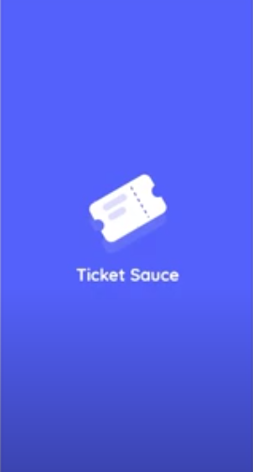

Figure No. 13 Loading Form

**Login Screen:**

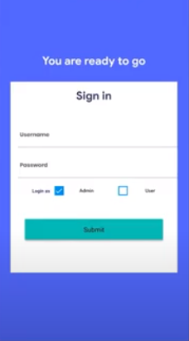

**Register :**

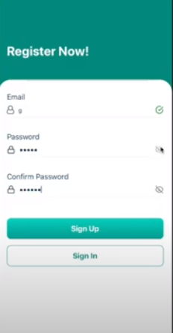

**Forgot Password Page:**

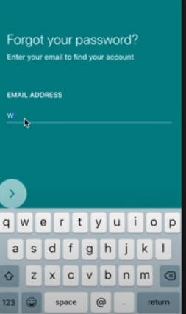

Figure No. 14 Forgot Password

**Valid user name:**

The user name field chek if the user name is valid then save. Otherwise it generate the Error.

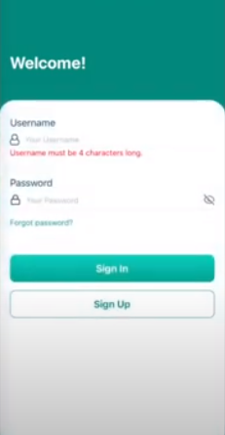

Figure No. 15 valid user name

**Valid Password:**

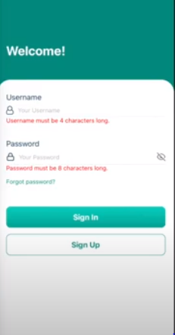

Figure No. 16 valid Passwerd

**List:**

List page contain all the register vehicles.List record save in the database

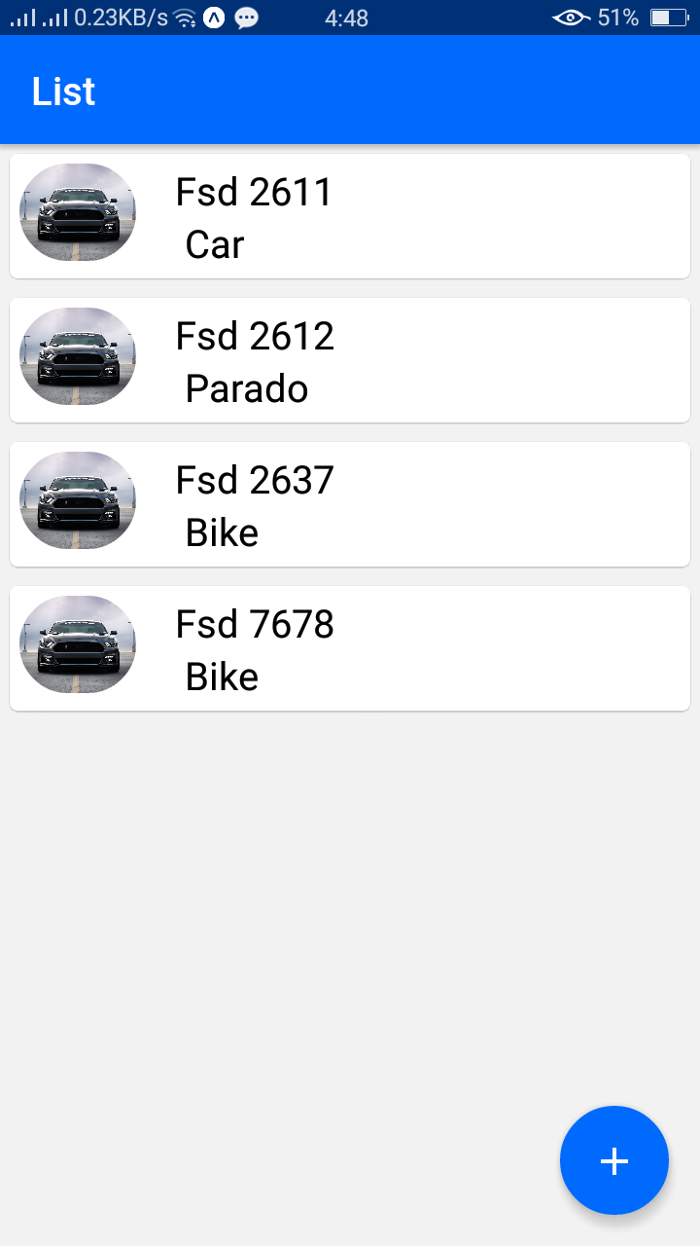

**Register vehicle:**

When the application user click on the plus button located I the rigth corner the reguster

Page open. It contain the vehicle number, vehicle type ,name ,discription and

Vehicle image also.

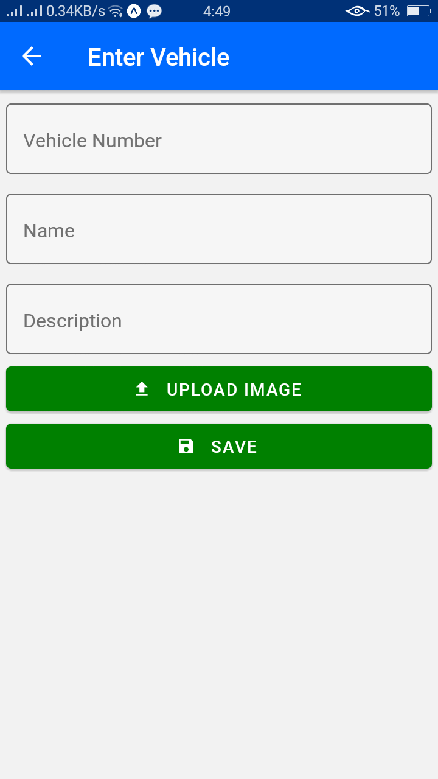

When you click in the upload image button this screen will appear. User can select the image

From gallery or directly click through the camera.

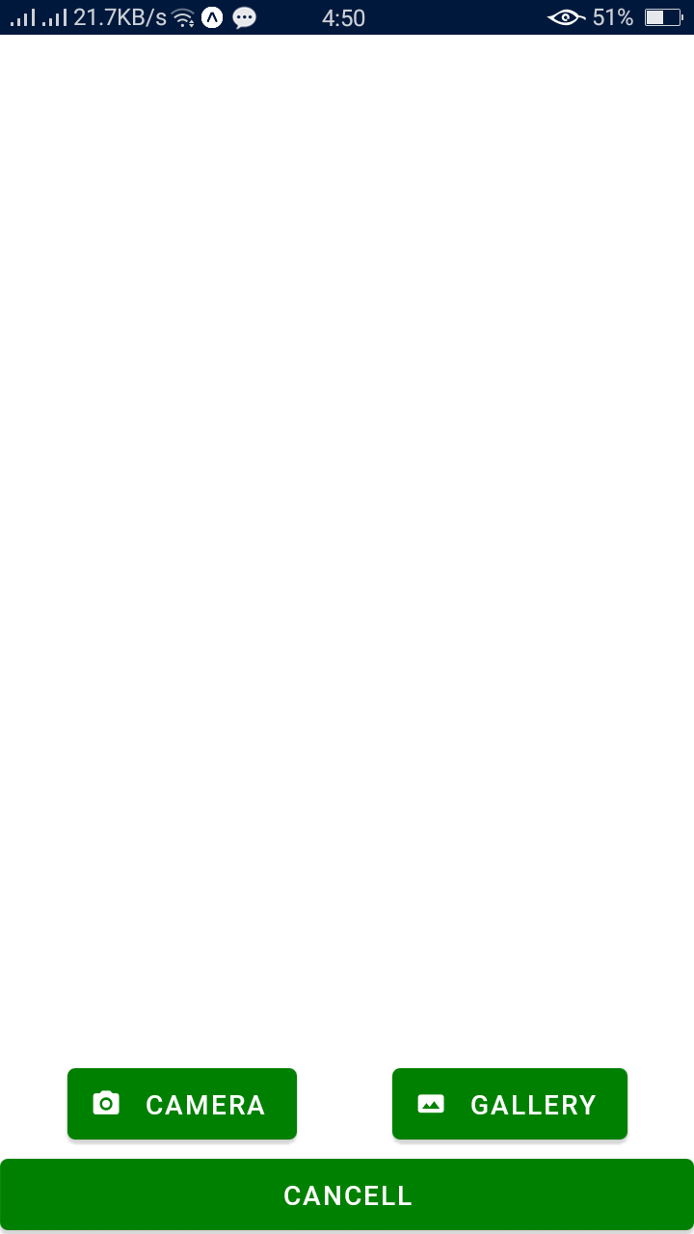

**Profile:**

Profile screen consist the user profile witch consist all the details like

Vehicle number, type ,image etc.

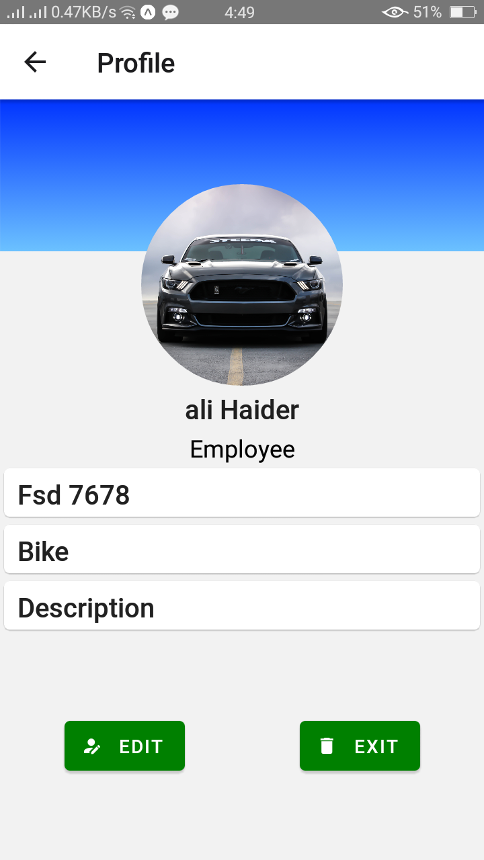

**Exit Or Out:**

When the customer or user used the parking and want to exit or out just simply click

On out button. It automatically exit the user from the list

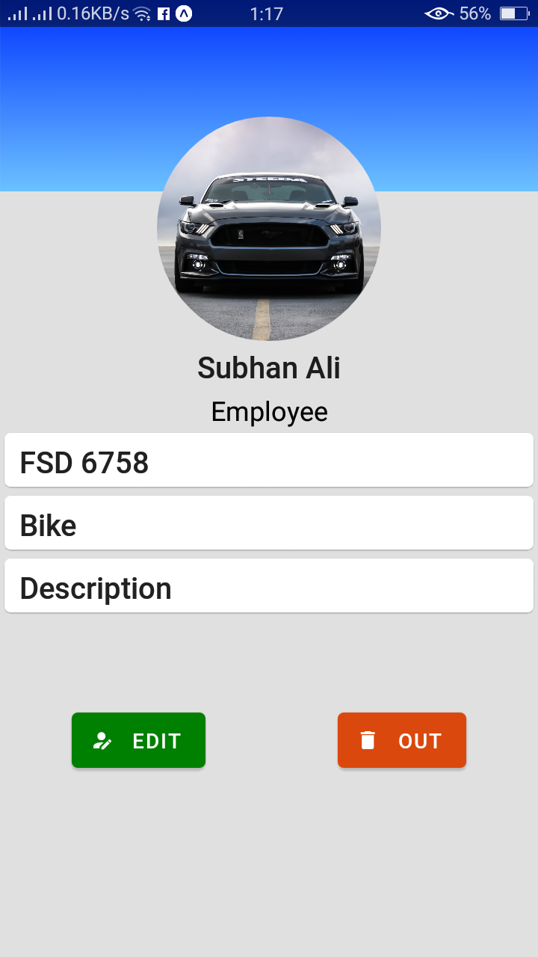

**Camera:**

After clicking the camera button the camera is ready to click the image.

